Sales Forecast by Seasons
SEIS -76301 – Machine Learning
July 18, 2018

Team members:
Sonal Kapur
Deepika Ravikumar
Shiyao Huang
Darius Nyaundi
Yu Fan

Table of Contents
Data Overview: 3
Visualizing data: 4
Models: 4
Logistic Regression: 4
Random forest: 7
SVM: 9
Ensemble: 11
Conclusion: 13
User Manual: 14

Data Overview:

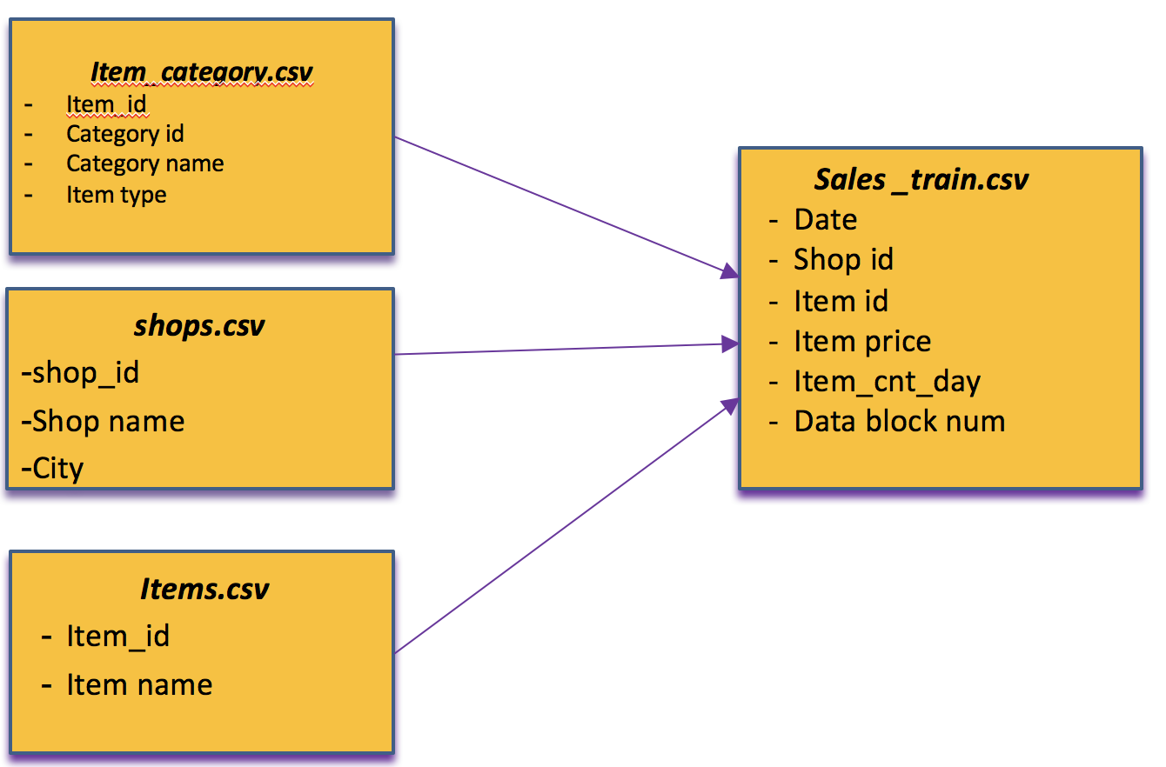

We were provided with three supplementary files and one main file. The 4 files were merged into the final dataset. The dummy variables were created for categorical variables and the standardization was done on the numeric variables.
After preprocessing, we were left with 17 predictors (including dummy variables) and with 50 K records. It is a binary class classification problem with Class 1 as Q1-Q2 and Class 0 as Q3-Q4. The processed dataset was then used to build different models.

Visualizing data:

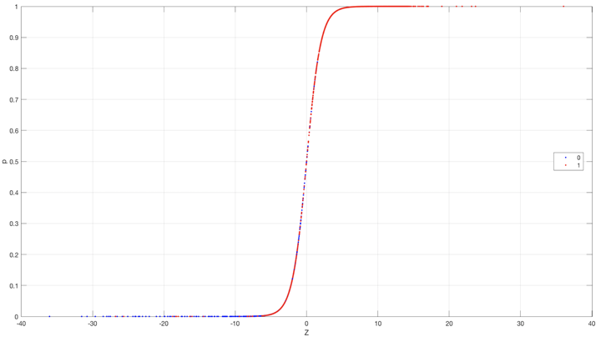
After visualizing the dataset, we found that there are lot of misclassifications around Z = 0 , and the red class is misclassified between -10 < z <= 0 .

Models:

Logistic Regression:

Introduction:

In order to figure out the best regularization parameter (c for python) for the logistic regression model, we ran the logistic regression with lasso and 10 folds of cross validation on our training data. The model with cross validation chose c=10000 regularization as the best (less error) model. However, we found once c is greater than 0.03, the error was minimized, so the result does not change as we switch any c above 0.03. In addition, the weights of each features do not change when the c is between 100 and 10000. so, we used c=100 to run logistic regression with lasso, the results show below.

Lasso Plot
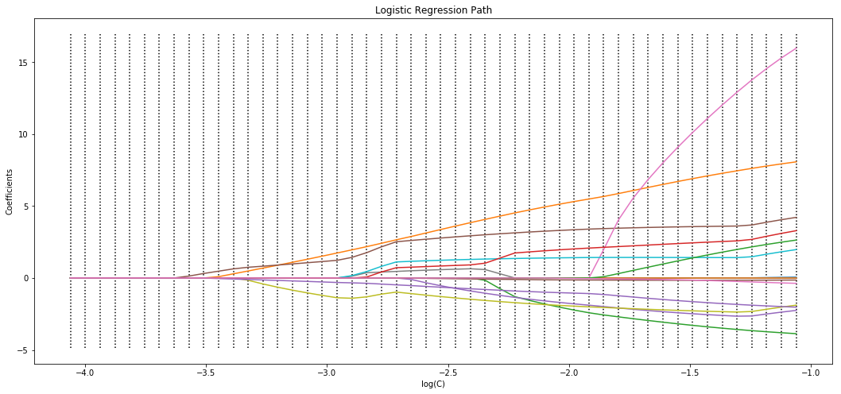

Calculated the prediction results based on different C values
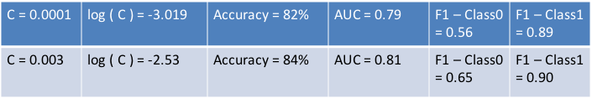

Results:
Accuracy : 0.85
Execution time : 0:00:02.66
MSE : 0.14
Variance score : 0.26
C : 100
AUC : 0.811 (Class 0 and Class 1)

Confusion Matrix w.r.t Class 0
 |  | Predicted
True Label | Class 0 | 1748 | 891
True Label | Class1 | 560 | 6981

Precision, Recall and F1 score Table:
 | Precision | Recall | F1-score | Support
0 | 0.76 | 0.66 | 0.71 | 2639
1 | 0.89 | 0.93 | 0.91 | 7541
avg/ total | 0.85 | 0.86 | 0.86 | 10180

Accuracy of 10 cross validation on training set when c=10000: [0.78,0.94,0.97,0.97,0.97,0.98,0.97,0.97,0.97,0.97]

ROC curve
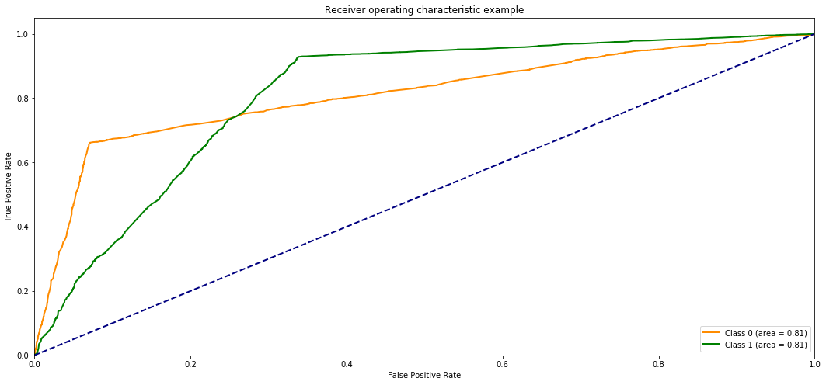

Important points from the result:

Based on the confusion matrix, the data is slightly unbalanced since the number of records in Class 0 are 2639 and Class 1 are, but still around 67% of the records of Class 0 are correctly classified.
Based on the F1 scores, we can see the model is more sensitive to predict Class 1. Though the AUC value is same for both classes but the ROC curve shows that Class 0 starts making mistakes earlier as compared to Class 1.

Random forest:

Overview:
A random forest is a collection of CART-like trees following specific rules for tree growing, tree combination, self-testing, and post-processing.
Random Forests grows many classification trees. To classify a test sample from an input vector, put the input vector down each of the trees in the forest. Each tree gives a classification, and we say the tree "votes" for that class. The forest chooses the classification having the most votes (over all the trees in the forest). Each tree is grown as follows:
If the number of cases in the training set is N, sample N cases at random - but with replacement, from the original data. This sample will be the training set for growing the tree. If there are M input variables, a number m<<M is specified such that at each node, m variables are selected at random out of the M and the best split on these m is used to split the node. The value of m is held constant during the forest growing. Each tree is grown to the largest extent possible. There is no pruning.
Regularization:
The way of regularization used for RF classifiers to limit the maximum allowable tree depth. To get rid of overfitting problem we tried different number of trees for the classification problem and saw the difference in accuracy between the training and test data set. We concluded with number of trees as 100 and maximum features to be selected as 6 for a tree. Thus, we used the maximum depth parameter as the regularization parameter – and made it smaller to reduce the overfitting and introduce bias. We used Gini Index with Random Forest to choose the important feature to be used during the split of a variable.
In other words, if in a tree in the forest, a split was already performed with feature i, and the gain (e.g., information gain) of feature i and feature j are similar, then the regularization will penalize feature j and will prefer feature i, that was selected previously.

Classification report:
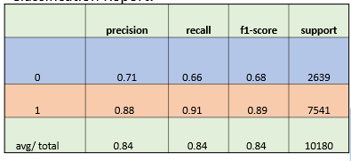
Confusion Matrix:
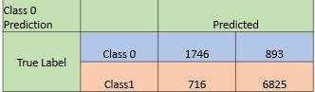
ROC Curve for Class 0 and Class 1:

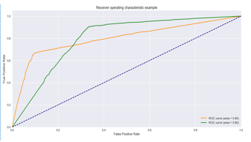
Accuracy : 84%
Execution time : 0:00:03.66
MSE : 0.16
50-50 split Accuracy : 84.45%
80-20 split accuracy : 83.34%
Variance score : 0.26
AUC : 80%
After the regularization, there seemed to be much difference between the 50-50 split and 80-20 split accuracy of classification. This shows that there is no overfitting of data in the model.
Our F1 score is more for class 1 than class 0. This shows that class 1 is predicted more accurately than class 0. Same goes for Precision. The data is slightly unbalanced since the number of false negative for class 0 is more than the number of true positive. Overall the prediction quality of the model is stable.

SVM:

Introduction:

We had to use hyper parameter tuning method for the SVM to fit the best linear Kernel and C value. Since our question is to predict the items sold in certain quarters, we want our model K and C to be tuned more towards precision. To find the best K and C we ran the grid search cv package from 1 to 1000. This is used for cross validation.

tuned_parameters = [{'kernel': ['linear'], 'C': [1, 10, 50, 100, 300, 500, 800, 1000]}]

Gridsearchcv runs all the hyper parameters and pick the best parameter with the highest grid score.

Tuning hyper-parameters for precision:

Best parameters set found on development set.
{'C': 300, 'kernel': 'linear'}

Grid scores on development set:
0.942 (+/-0.145) for {'C': 1, 'kernel': 'linear'}
0.945 (+/-0.148) for {'C': 10, 'kernel': 'linear'}
0.945 (+/-0.148) for {'C': 50, 'kernel': 'linear'}
0.946 (+/-0.148) for {'C': 100, 'kernel': 'linear'}
0.946 (+/-0.148) for {'C': 300, 'kernel': 'linear'}
0.946 (+/-0.148) for {'C': 500, 'kernel': 'linear'}
0.946 (+/-0.148) for {'C': 800, 'kernel': 'linear'}
0.946 (+/-0.148) for {'C': 1000, 'kernel': 'linear'}

Now we have to find the accuracy of the model. To do that we must first run a confusion matrix. After we run the confusion matric we can run the accuracy code to calculate the accuracy of our model as well.

Confusion Matrix w.r.t Class 0
 |  | Predicted
True Label | Class 0 | 1749 | 890
True Label | Class1 | 604 | 6937

Accuracy: 0.85

Since our dataset is unbalanced, so just checking the accuracy as the only quality parameter will not be considered reliable in order to conclude the prediction quality of the model, so we calculated precision and recall as well by running the classification report for test dataset. Once we have our precision and recall we need to find out which class (0 or 1) performs better by calculating the F-score. We want the F1-score to be the highest score. The higher the score, the closer to precision the class is.

Precision, Recall and F1 score Table:
 | Precision | Recall | F1-score | Support
0 | 0.74 | 0.66 | 0.70 | 2639
1 | 0.89 | 0.92 | 0.90 | 7541
avg/ total | 0.85 | 0.85 | 0.85 | 10180

Lastly, we generated the ROC curve to determine how great our test is in determining our items for each of the quarters. We want our ROC curve to lean closer to the true positive for best results.
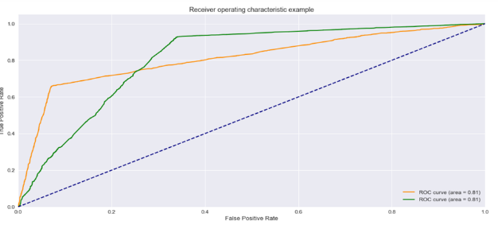

Ensemble:

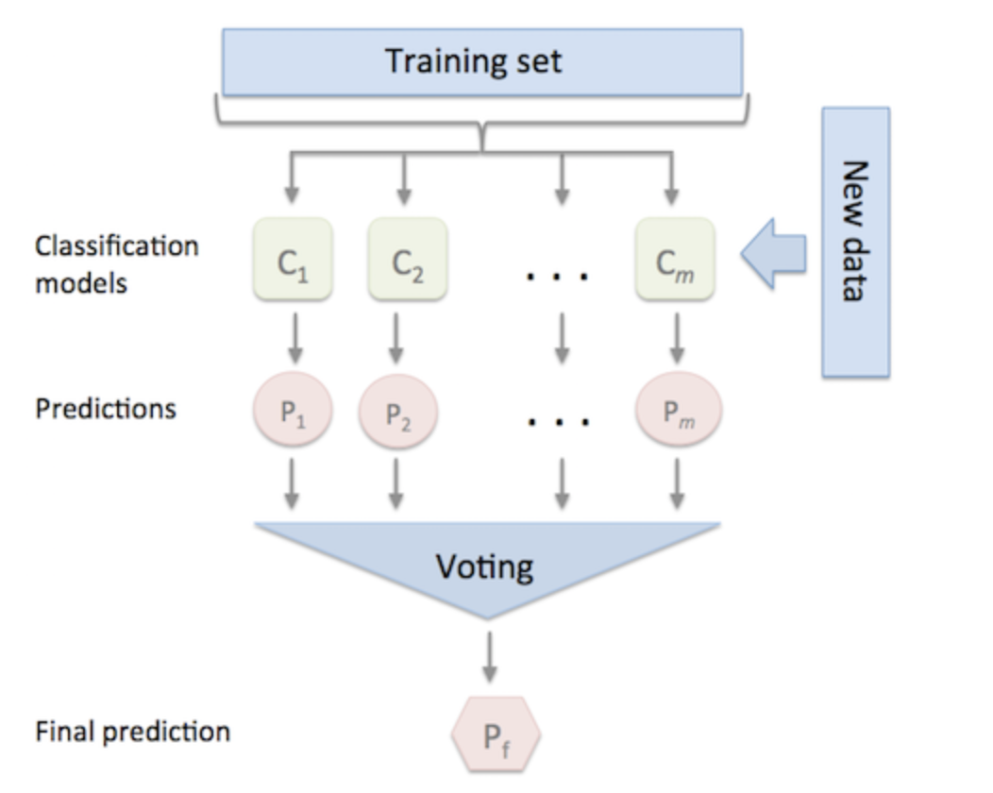

The three trained classification models (Random Forest, Logistic Regression, SVM) were combined by the voting classifier (hard voting) and used a majority vote and average predicted probabilities (soft voting) to predict the class labels. Such a classifier can be useful for a set of equally well performing model in order to balance out their individual weaknesses.

Accuracy of each model:

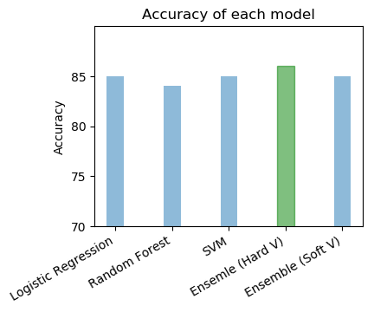

- We were able to achieve the 1% increase in accuracy (86%) through ensemble hard voting.

F1 Score of each model:
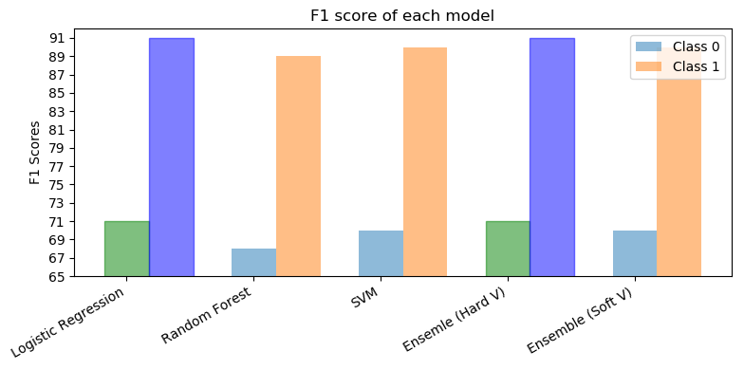

- The F1 score of Ensemble Hard Voting is same as the F1 score of Logistic Regression.

Conclusion:

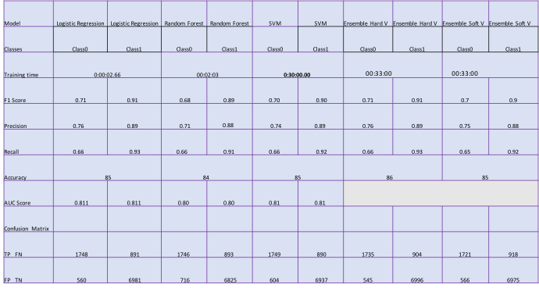

- Some of the important Predictors –
- Gifts (Soft Toys, Souvenirs, Games) ->> Class 0 [Q3-Q4]
- Cinema (DVDs , BlueRay 3D ) ->> Class 1[ Q1-Q2]
- SVM took the maximum time while training the model.
- By using Ensemble, we were able to increase the accuracy of the model by 1%

User Manual:

General Guidelines:

- All the programs are built using Python programming language with Jupyter Notebook and Spyder as IDE .
- The input filenames used in all the models: X_train.csv, Y_train.csv, X_test.csv, Y_test .csv
- These files are included in the final project submission.

Steps:
- To run Logistic Regression:

Run program Log_Reg.ipynb in Jupiter Notebook and modify the path of the input files accordingly.

- To run Random Forest:

Run program RF.py in spyder IDE or convert the extension into ipynb in order to run the program in Jupyter Notebook. Also, modify the path of the input files.

- To run SVM:

Run program svm.ipynb in Jupyter Notebook and modify the path of the input files accordingly.

- To run Ensemble:

Run program Ensemble.ipynb and modify the path of the input files accordingly.

